Spring Bean Lifecycle
Between:
“Spring created the object” “Application is using the object” multiple phases occur.
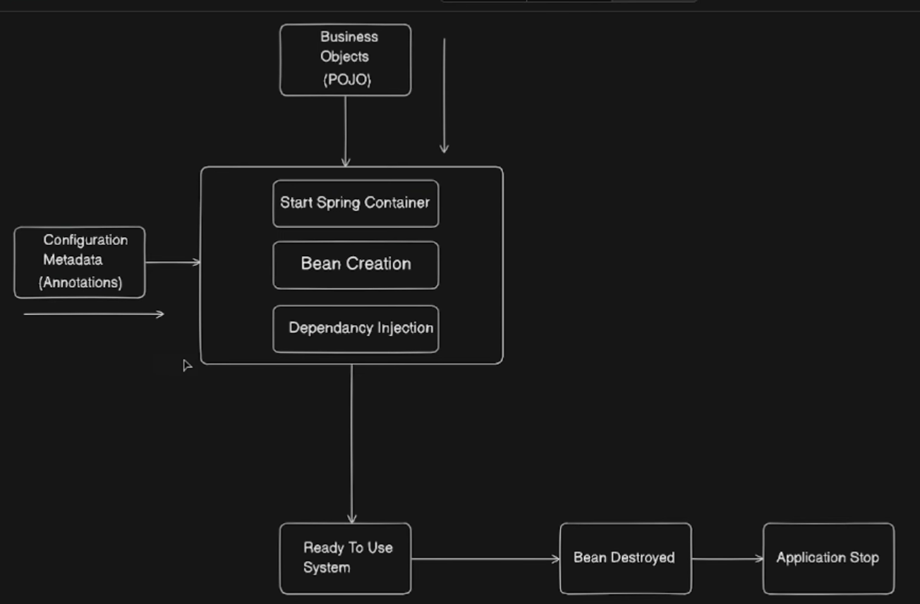
When a Spring application starts, the Spring Container (ApplicationContext) is created first.
Once the container is up, Spring begins scanning configuration metadata (annotations, XML, or Java config).
Using this metadata, Spring:
- Identifies POJOs (business classes)
- Creates objects for them
- Converts them into Spring Beans
- Stores them inside the Spring Container
During bean creation, Spring notices that many beans depend on other beans.
So before a bean is ready:
- Required dependencies are created
- Dependencies are injected into the bean
- Wiring between beans is completed
After this process, beans become fully initialized and ready to use.
The application then uses these beans throughout its execution.
When the application is stopped:
- The Spring Container shuts down
- Spring triggers destruction callbacks
- Beans release resources
- Finally, the application terminates
This entire journey — from bean creation to dependency injection, usage, and destruction — is called the Spring Bean Lifecycle.

How does a bean actually move through its lifecycle?

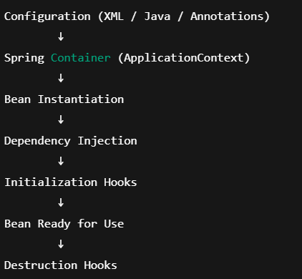

Example Setup
Service Class (Bean)
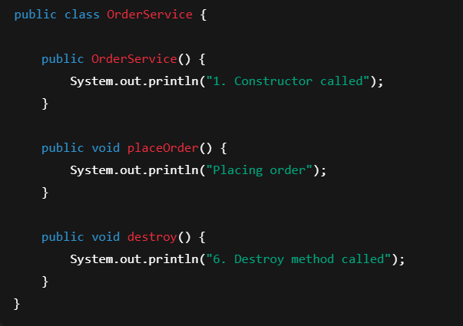
XML Configuration
beans.xml
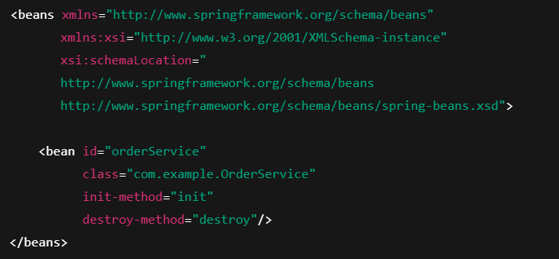
Now let’s add the init method.
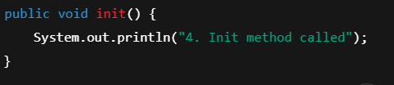
Creating the Spring Container (ApplicationContext)
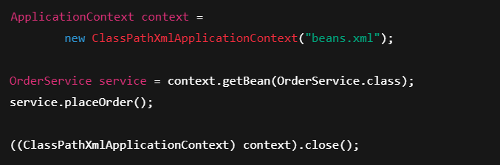

Execution Order
When you run this, output will be:
1. Constructor called
4. Init method called
Placing order
6. Destroy method called
Now let’s map this to lifecycle stages.

Lifecycle Stages Mapped to Code
1. Instantiation
new OrderService();
Triggered by Spring, not by developer.
2. Dependency Injection
(Spring injects dependencies here — skipped in this simple example)
3. Initialization
- init-method
- or @PostConstruct
- or afterPropertiesSet()

4. Bean Ready for Use
service.placeOrder();

5. Destruction
Triggered when:
context.close();
Spring calls:
- destroy-method
- or @PreDestroy

Same Lifecycle Using Annotations (Modern Way)
Bean Class
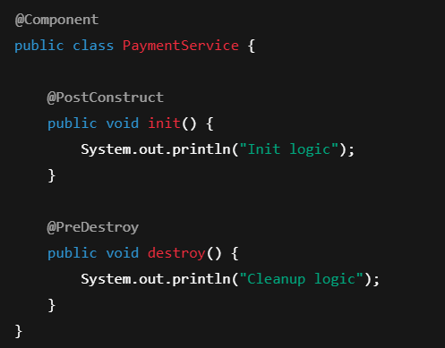
Container Creation
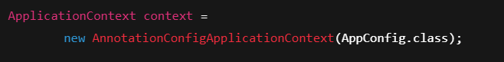

Configuration Class
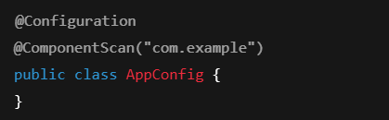
@PostConstruct runs after dependency injection
@PreDestroy runs before container shutdown

Frequently Asked Interview Questions
Q1. When is a bean fully ready for use?
After:
- Dependency Injection
- Initialization callbacks
- Post-processors
Q2. Why avoid heavy logic in constructors?
Because dependencies may not be injected yet.
Q3. Difference between @PostConstruct and constructor?
Constructor → object creation
@PostConstruct → post-injection initialization
Q4. Who controls bean destruction?
Spring Container, not JVM directly.
One-Line Summary
“Spring manages the complete lifecycle of a bean — from instantiation to destruction — using the container and lifecycle hooks.”

